CMIS102 Homework Assignment 2

Student Name: Reece Zunino
Class/Section: CMIS102
Professor Name: David Castillo
Assignment due date: February 2, 2015

Problem Definition: Calculate the total price based on several key parts required to build a state-of-the-art gaming computer. The user will have the option of selecting different parts. For example, Windows 7, Windows 8 or Mac OS/X for Operating systems, 4 GB, 8 GB or 12 GB for RAM and 15”,17” or 22” Monitors etc...

- Problem Analysis – This section describes the problem analysis of the assignment.
- Objective: Devise a program that calculates the total price to build a state-of-the-art gaming computer
Item | Option | Option Description | Price
Base Price | - | Basic Design | 500.00
CPU | 1 | 2.3GhZ | 325.00
 | 2 | 3.0 GhZ | 250.00
 | 3 | 3.4 GhZ | 375.00
Case | 1 | White Windowed | 99.99
 | 2 | Black Windowed | 199.99
 | 3 | Gray Window Metal | 299.99
Power Supply | 1 |  | 99.99
 | 2 |  | 59.99
Motherboard | 1 |  | 299.99
 | 2 |  | 159.99
Hard Drive | 1 | 250GB | 199.99
 | 2 | 500GB | 299.99
 | 3 | 1TB | 399.99
Ram | 1 | 4GB | 49.99
 | 2 | 16GB | 199.99
 | 3 | 32GB | 399.99
DVD Drive | 1 | Normal | 99.99
 | 2 | Blue-Ray | 199.99
Graphics Card | 1 |  | 349.99
 | 2 |  | 499.99
 | 3 |  | 699.99
Sound Card | 1 |  | 99.99
 | 2 |  | 199.99
Monitor | 1 | 22” Screen | 249.99
 | 2 | 27” Screen | 399.99
Operation System (OS) | 1 | Windows 7 | 199.99
 | 2 | Windows 8 | 299.99
 | 3 | MAC OSX | 399.99

- Outputs:
  - Total Price of Computer:
    - TotalPrice (as a Float variable)

- Inputs:
  - Collect input data on the required parts for the computer.

- Base Price Variables and Options: There are no options for the base price only an established price (from the table)
  - BasePrice As Float
  - Set BasePrice = 500

    - CPU Option Variables:

- Option As Integer – (has values of 1, 2, and 3 from your table)
- Description As String – (has values of 2.3GhZ, 3.0GhZ, and 3.4Ghz)
- Price As Float – (has values of 20, 40, and 60

- Write “Select your CPU Option. Enter 1, for 2.3GhZ, 2 for 3.0GhZ, and 3 for 3.4Ghz” Input Option

      - Select Option of CPUOption
      - Option 1: Set CPUDescription = “2.3GhZ” Set Price = 325.00
Break
      - Option 2: Set CPUDescription = “3.0GhZ” Set Price = 250.00
Break
      - Option 3: Set CPUDescription = “3.4GhZ” Set Price = 375.00
End Select
    - Case Option Variables:

- CaseOption As Integer – (has values of 1, 2, and 3 from your table)
- Price As Float – (has values of 99.99, 59.99, and 299.99

- Write “Select your CPU Option. Enter 1, 2 and 3”

- Input Option

      - Select Case of CaseOption
      - Option 1: Set Price = 99.99
Break
      - Option 2: Set Price = 199.99
Break
      - Option 3: Set Price = 299.99
End Select

    - Power Supply Option Variables:

- PowerSupplyOption As Integer – (has values of 1 and 2 from your table)
- Price As Float – (has values of 99.99 and 59.99)

- Write “Select your Power Supply Option. Enter 1 and 2”

- Input Option

      - Select Option of PowerSupplyOption
      - Option 1: Set Price = 99.99
Break
      - Option 2: Set Price = 59.99
End Select

    - Motherboard Option Variables:

- MotherboardOption As Integer – (has values of 1 2 from your table)
- Price As Float – (has values of 299.99 and 399.99)

- Write “Select your Motherboard Option. Enter 1 and 2”

- Input Option

      - Select option for MotherboardOption
      - Option 1: Set Price = 299.99
Break
      - Option 2: Set Price = 399.99
End Select

    - Hard Drive Option Variables:

- Option As Integer – (has values of 1, 2, and 3 from your table)
- Description As String – (has values of 250GB, 500GB, and 1TB)
- Price As Float – (has values of 199.99, 299.99, and 399.99)

- Write “Select your Hard Drive Option. Enter 1, for 250GB, 2 for 500GB, and 3 for 1TB”

    - Input Option

      - Select Option of HardDriveOption
      - Option 1: Set HardDriveOption = “2.3GhZ” Set Price = 199.99
Break
      - Option 2: Set HardDriveOption = “3.0GhZ” Set Price = 299.99
Break
      - Option 3: Set HardDriveOption = “3.4GhZ” Set Price = 399.99
End Select

    - RAM Option Variables:

- Option As Integer – (has values of 1, 2, and 3 from your table)
- Description As String – (has values of 4GB, 16GB, and 32GB)
- Price As Float – (has values of 49.99, 199.99, and 399.99)

- Write “Select your RAM Option. Enter 1, for 4GB, 2 for 16GB, and 3 for 32GB”

    - Input Option

      - Select Option of RAMOption
      - Option 1: Set RAMOption = “2.3GhZ” Set Price = 49.99
Break
      - Option 2: Set RAMOption = “3.0GhZ” Set Price = 199.99
Break
      - Option 3: Set RAMOption = “3.4GhZ” Set Price = 399.99
End Select

    - DVD Option Variables:

- DVDOption As Integer – (has values of 1 2 from your table)
- Description As String – (has values of normal, and blue-ray)
- Price As Float – (has values of 99.99 and 199.99)

- Write “Select your DVD Option. Enter 1 and 2”

- Input Option

      - Select option for DVDOption
      - Option 1: Set DVDOption = “normal” Set Price = 99.99
Break
      - Option 2: Set DVDOption = “blue-ray” Set Price = 199.99
End Select

    - Graphics Card Option Variables:

- Option As Integer – (has values of 1, 2, and 3 from your table)
- Price As Float – (has values of 349.99, 499.99, and 699.99)

- Write “Select your Graphics Card Option. Enter 1, 2, or 3)

    - Input Option

      - Select Option of GraphicsCardOption
      - Option 1: Set Price = 349.99
Break
      - Option 2: Set Price = 499.99
Break
      - Option 3: Set Price = 699.99
End Select

    - Sound Card Option Variables:

- SoundCardOption As Integer – (has values of 1 2 from your table)
- Price As Float – (has values of 99.99 and 199.99)

- Write “Select your Sound Card Option. Enter 1 and 2”

- Input Option

      - Select option for SoundCardOption
      - Option 1: Set Price = 99.99
Break
      - Option 2: Set Price = 199.99
End Select

    - Monitor Option Variables:

- MonitorOption As Integer – (has values of 1 2 from your table)
- Price As Float – (has values of 249.99 and 399.99)

- Write “Select your Monitor Option. Enter 1 and 2”

- Input Option

      - Select option for MonitorOption
      - Option 1: Set Price = 249.99
Break
      - Option 2: Set Price = 399.99
End Select

    - OS Option Variables:

- Option As Integer – (has values of 1, 2, and 3 from your table)
- Description As String – (has values of Windows 7, Windows 8, and MAC OSX)
- Price As Float – (has values of 199.99, 299.99, and 399.99)

- Write “Select your Hard Drive Option. Enter 1, for Windows 7, 2 for Windows 8, and 3 for MAC OSX”

    - Input Option

      - Select Option of OSOption
      - Option 1: Set OSOption = “windows 7” Set Price = 199.99
Break
      - Option 2: Set OSOption = “windows 8” Set Price = 299.99
Break
      - Option 3: Set OSOption = “MAC OSX” Set Price = 399.99
End Select

- Calculation Approach:
  - Total Price = Sum of the Parts Chosen by the consumer for the final computer build
    - TotalPrice = BaselineCost + CaseOption1-3 + CPUOption1-3+ DVDOption1-2+ GraphicsCardOption1-3+ HardDriveOption1-3+ MotherboardOption1-2+ MonitorOption1-2+ SoundCardOption1

- Program Design – This section describes the program design used to solve the problem.
- Hierarchy Diagram:

Main Module
Computer Price Calculator
Input
Module
GetData
Calculation
Module
CalculateTotalPrice
Output
Module
DisplayTotalPrice

  - Main Module (main) – Controls program execution including start and end. Declare all variables in this section.
    - Declare CPUOption 1-3 As Float
    - Declare CPUOption As Float
    - Declare CaseOption 1-3 As Float
    - Declare CaseOption AS Float
    - Declare PowerSupplyOption 1-2 As Float
    - Declare PowerSupplyOption As Float
    - Declare MotherboardOption 1-2 As Float
    - Declare MotherboardOption As Float
    - Declare HardDriveOption 1-3 As Float
    - Declare HardDriveOption As Float
    - Declare RAMOption 1-3 As Float
    - Declare RAMOption As Float
    - Declare DVDOption 1-2 As Float
    - Declare DVDOption As Float
    - Declare GraphicsCardOption 1-3 As Float
    - Declare GraphicsCardOption As Float
    - Declare SoundCardOption 1-2 As Float
    - Declare SoundCardOption As Float
    - Declare MonitorOption 1-2 As Float
    - Declare MonitorOption As Float
    - Declare OSOption 1-3 As Float
    - Declare OSOption As Float
    - Declare TotalPrice As Float

  - Input Module (GetData) – Prompts the user to make selections based on preference of parts for the computer.
    - Input CPUOption
      - Select CPUOption 1-3
- Input CaseOption
      - Select CaseOption 1-3
- Input PowerSupplyOption
  - Select PowerSupply Option 1-2
    - Input MotherboardOption
      - Select MotherboardOption 1-3
- Input HardDriveOption
      - Select HardDriveOption 1-3
- Input RAMOption
  - Select RAMOption Option 1-3
    - Input DVDOption
      - Select DVDOption 1-2
- Input GraphicsCardOption
      - Select GraphicsCardOption 1-3
- Input SoundCardOption
  - Select SoundCardOption Option 1-2
    - Input MonitorOption
      - Select MonitorOption 1-
- Input OSOption
      - Select OSOption 1-3

  - Calculation Module (CalculateArea) – Applies the formulas identified in the Analysis Phase to compute the Total Price for the computer for the parts the user has chosen.
    - CaseOption1-3 + CPUOption1-3+ DVDOption1-2+ GraphicsCardOption1-3+ HardDriveOption1-3+ MotherboardOption1-2+ MonitorOption1-2+ SoundCardOption1-2+ RAMOption1-3+ PowerSupplyOption1-2+ OSOption1-3+ BaseLinePrice

  - Output Module (DisplayArea) – Displays the results of the program that were specified in the Analysis Phase
    - Output TotalPrice

  - Flow Diagram – The Raptor flow diagram illustrating the logic flow of the program is as follows:

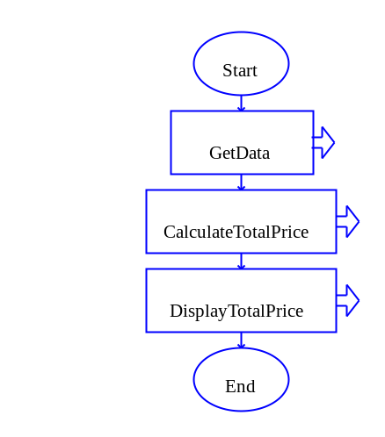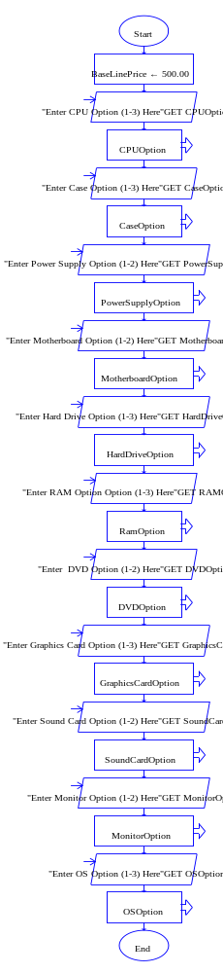
Main Module GetData Module

CaseOption Selection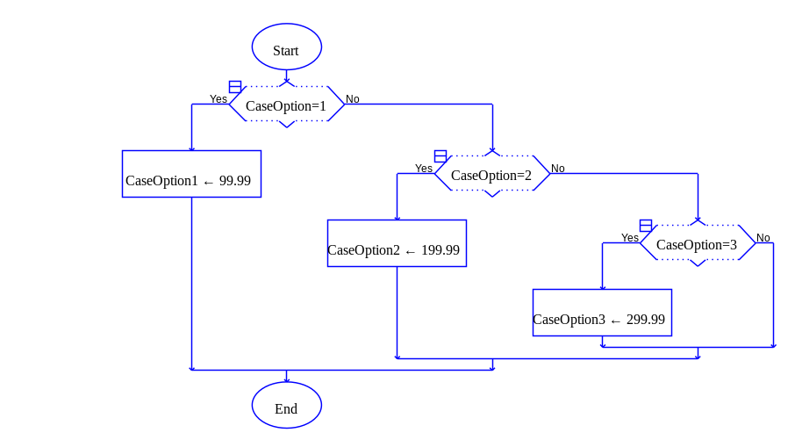

MotherBoardSelection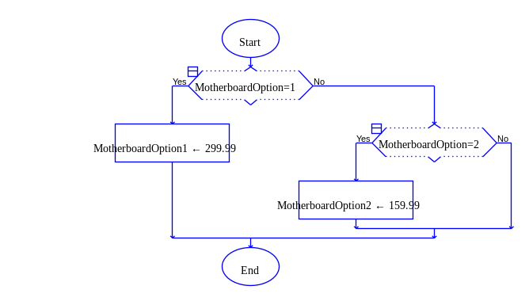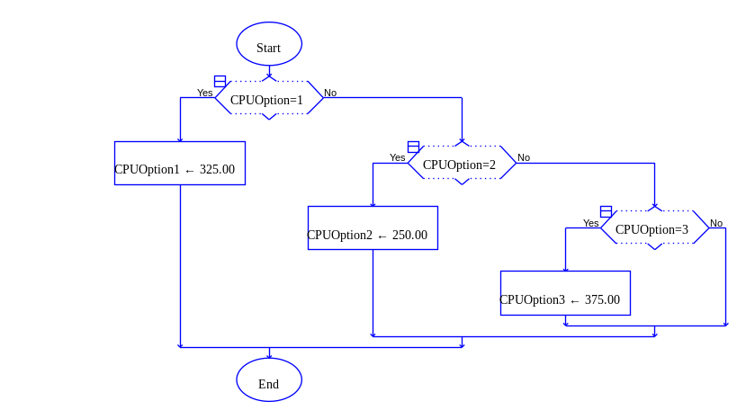CPUOption Selection
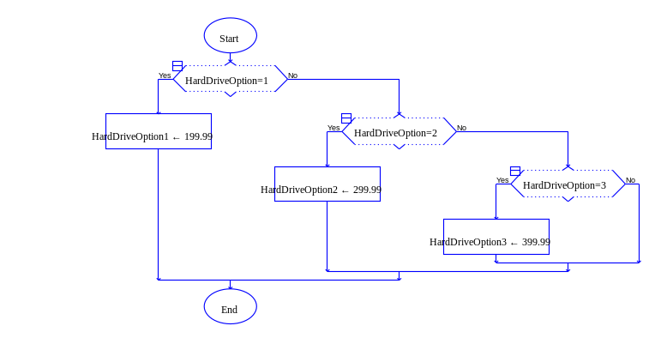HarddriveOption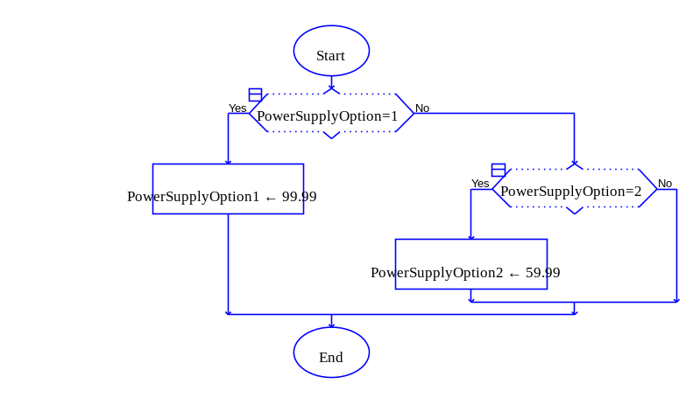PowerSupplyOption
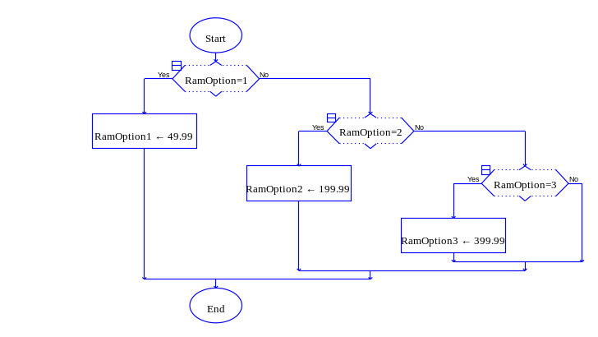RAMOption
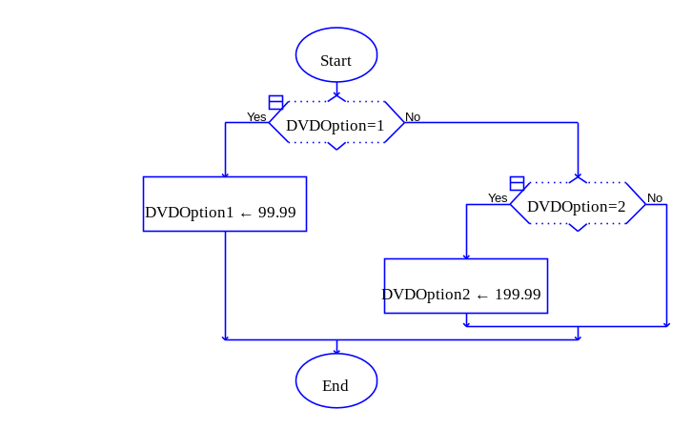DVDOption
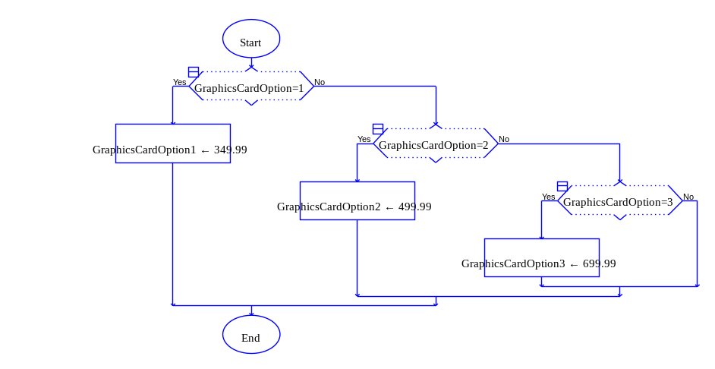GraphicsCardOption
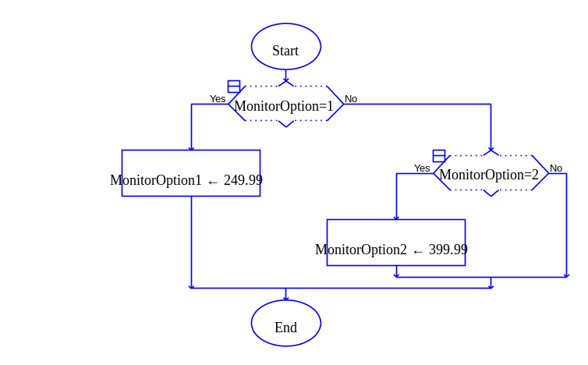MonitorOption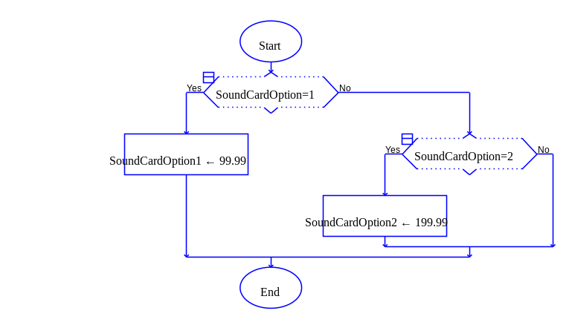SoundCardOption
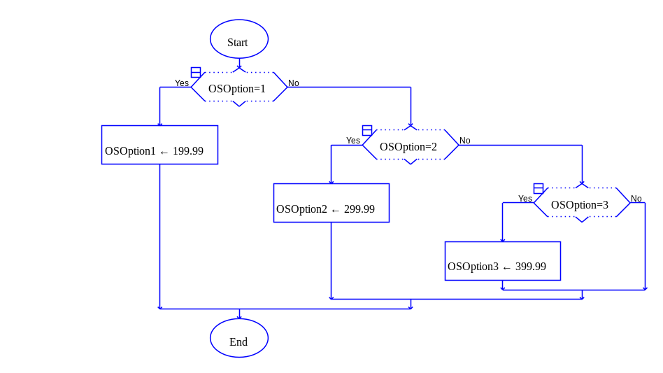OSOption
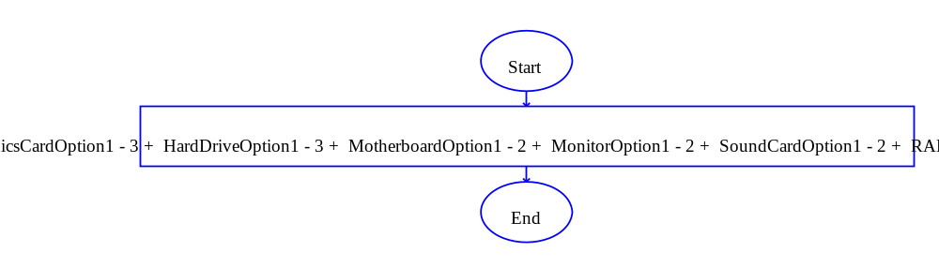 CalculateTotalPrice Module

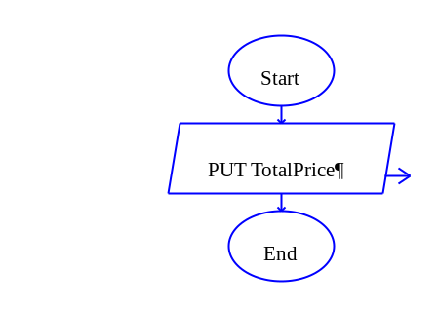
DisplayTotalPrice Module

- Program Pseudocode – This section describes the program pseudocode used to solve the problem.
// Computer Price Calculator
// Programmer: Reece Zunino
// Version 1.0, 2/1/2015

Main module
// Declare the Part Price Variables
Declare CPUOption 1-3 As Float
Declare CPUOption As Float
Declare CaseOption 1-3 As Float
Declare CaseOption AS Float
Declare PowerSupplyOption 1-2 As Float
Declare PowerSupplyOption As Float
Declare MotherboardOption 1-2 As Float
Declare MotherboardOption As Float
Declare HardDriveOption 1-3 As Float
Declare HardDriveOption As Float
Declare RAMOption 1-3 As Float
Declare RAMOption As Float
Declare DVDOption 1-2 As Float
Declare DVDOption As Float
Declare GraphicsCardOption 1-3 As Float
Declare GraphicsCardOption As Float
Declare SoundCardOption 1-2 As Float
Declare SoundCardOption As Float
Declare MonitorOption 1-2 As Float
Declare MonitorOption As Float
Declare OSOption 1-3 As Float
Declare OSOption As Float
Declare TotalPrice As Float

// Declare the Area Variables
Declare AreaRoom1, AreaRoom2, AreaRoom3, AreaRoom4 As Float

// Declare the Total Area
Declare TotalArea As Float

// Now call the module for acquiring the program data
// and setting the values on the above declared variables
Call GetData module

// Call the module for performing the price calculations
Call CalculatePrice module

// Display the results of the price calculations
Call DisplayPrice module

End Program

// GetData Module is designed to acquire the selection the user wishes to have in the computer to acquire the pricing for final calculation

GetData module
// Prompt the user for the selection for CPUOption 1-3 the computer design Write “CPUOption 1-3”
Input CPUOption 1-3
Select CPUOption Price

// Prompt the user for the selection for PowerSupplyOption 1-2 the computer design Write “PowerSupplyOption 1-2”
Input PowerSupplyOption 1-2
Select PowerSupplyOption Price

// Prompt the user for the selection for MotherboardOption 1-2 the computer design Write “MotherboardOption 1-2”
Input MotherboardOption 1-3
Select MotherboardOption Price

// Prompt the user for the selection for HardDriveOption 1-3 the computer design Write “HardDriveOption 1-3”
Input HardDriveOption 1-3
Select HardDriveOption Price

// Prompt the user for the selection for RAMOption 1-3 the computer design Write “RAMOption 1-3”
Input RAMOption 1-3
Select RAMOption Price

// Prompt the user for the selection for DVDOption 1-2 the computer design Write “DVDOption 1-2”
Input DVDOption 1-2
Select DVDOption Price

// Prompt the user for the selection for
Option 1-3 the computer design Write “GraphicsCardOption 1-3”
Input CPUOption 1-3
Select CPUOption Price

// Prompt the user for the selection for CPUOption 1-3 the computer design Write “GraphicsCardOption 1-3”
Input GraphicsCardOption 1-3
Select GraphicsCardOption Price

// Prompt the user for the selection for SoundCardOption 1-2 the computer design Write “SoundCardOption 1-2”
Input SoundCardOption 1-2
Select SoundCardOption Price

// Prompt the user for the selection for MonitorOption 1-2 the computer design Write “MonitorOption 1-2”
Input MonitorOption 1-2
Select MonitorOption Price

// Prompt the user for the selection for OSOption 1-3 the computer design Write “OSOption 1-3”
Input OSOption 1-3
Select OSOption Price

End Program

// CalculatePrice Module computes all parts selected by the user to give the user a total price for the computer

CalculatePrice module
// Compute the individual parts for the computer
CaseOption1-3 + CPUOption1-3+ DVDOption1-2+ GraphicsCardOption1-3+ HardDriveOption1-3+ MotherboardOption1-2+ MonitorOption1-2+ SoundCardOption1-2+ RAMOption1-3+ PowerSupplyOption1-2+ OSOption1-3+ BaseLinePrice

End Program

// DisplayPrice module outputs the total Price of the computer for the user
DisplayArea module
// Display the total price of computer

End Program

- Program Test Table – This section shows the program test table you used to validate your outputs.

Input: | Expected Output:
Base Line  CPU 1  Case 2  Power supply 1  Motherboard 2  Hard Drive 3  RAM 1  DVD 2  Sound Card 1  Monitor 1  Graphics Card 1  Operating System 2 | Total Price: 1646.95
Base Line  CPU 2  Case 1  Power supply 2  Motherboard 1  Hard Drive 1  RAM 2  DVD 1  Sound Card 2  Monitor 2  Graphics Card 3  Operating System 1 | Total Price: 1371.95
Base Line  CPU 3  Case 3  Power supply 1  Motherboard 2  Hard Drive 1  RAM 3  DVD 2  Sound Card 1  Monitor 1  Graphics Card 1  Operating System 3 | Total Price:1321.95

